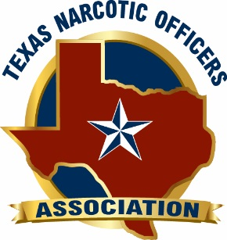 Texas Original 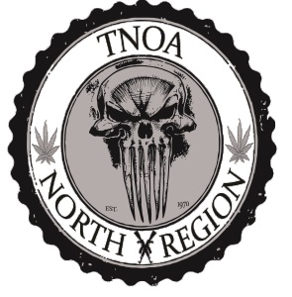

Criminal Patrol/Drug Interdiction
November 18, 2016

This is an 8 hour specialized class for Street Crimes, Patrol Officers and Highway Interdiction Officers. The objective of this course is to educate law enforcement officers in proper techniques and procedures to successfully and lawfully conduct criminal interdiction patrol stops. Instructors will cover and show the student how to conduct a comprehensive and systematic vehicle search. Instructors will provide vehicles for students to have a “hands on approach” during an actual vehicle search. This course provides a basic look at concealment methods used by contraband smugglers. These compartments are used by the drug cartels in Mexico to pass their weapons of mass destruction as well as funds and drugs through the United States interior. Theses compartments are very common and thousands of them are being seized on our borders and throughout our country yearly. These tactics are designed and used by smugglers with great success in defeating common police searches. You will be given an in-depth look into the various concealment methods used by contraband smugglers. We will have several photographic and video examples of actual hidden compartments, and modified natural voids. This course will expose tactics used to detect hidden compartments in passenger vehicles.
Instructor Bio:

Keith Carlton graduated from the police academy in 2002 and served 6 years with Rowlett Police. In 2008 Keith Carlton transferred to Garland Police where he currently works as a Narcotics Investigator. Keith Carlton has 14 years total in Law Enforcement. Additionally, he is the Sergeant at Arms for the Texas Narcotics Officers Association. Keith Carlton holds a Master Peace Officer certificate and has over 2400 hours of specialized training.

Instructor Bio:
Robert Pemberton master peace officer with 20 plus years law enforcement experience. Pemberton worked 10 years as K-9 and Criminal Interdiction Officer working IH-30 in Hunt County Texas. Pemberton has made hundreds of narcotics and money seizures cases along with finding numerous hidden compartments in passenger vehicles and commercial motor vehicles. He has worked successfully with local, state and federal agencies and has received hundreds of hours in specialized training in the field of criminal interdiction as well hands on training with Border Patrol.

Payment instructions:

The fee for the course is $30.00 for TNOA members and $50.00 for non-members. Credit card payments are strongly recommended. Payments (checks) should be mailed to David Galvan 1891 Forest Ln. Garland, Tx 75042. Inquiries regarding the course, payment or other questions can be directed to galvan@garlandtx.gov 214-695-3727. All fees are due by November 11, 2016.

Location:

Fletcher Warren Civic Center
5501 Business 69, Greenville, Texas 75402

